**Interactive Tutorial**

**On**

**Linear Programming**

**A Project Report**

**Submitted by:**

**Divya Harita (IU1783830012)**

in partial fulfillment for the award of the degree

of

**Integrated Master of Science**

**Semester VI**

at



**Department of Computer Science**

**INDUS UNIVERSITY**

**2020**



**CERTIFICATE**

This is to certify that the project titled “Interactive Tutorial on Linear Programming” is the bona fide work carried out by Divya Harita, a student of Integrated Master of Science during the academic year 2020, in partial fulfillment of the requirements for the award of the degree of Integrated Master of Computer Application Semester V.

|  |  |
| --- | --- |
| **Internal Guide Signature :** | **Head of Dept. Signature :** |
| **Date :** | **Date :** |

|  |  |  |
| --- | --- | --- |
| **Sr. No.** | **Contents** | **Page No.** |
|  | **Acknowledgement** |  |
|  | **Introduction** |  |
|  | **Existing system** |  |
|  | **Problem areas of existing system** |  |
|  | **Need for the new system** |  |
|  | **Proposed System** |  |
|  | **System Flow Diagram** |  |
|  | **User Interface Screens** |  |
|  | **Test Plan and Test Cases** |  |
|  | **Future Enhancement** |  |
|  | **References / Bibliography** |  |

**Acknowledgements:**

Special thanks to my project guide Prof Krishna Modi and HOD, Dr Vishal Dahiya for giving me the opportunity to do the project and guiding us at every stage. Without their support it would have been very difficult for me to do this project. I have developed this Online interactive tutorial by following the best industry practices and by using the modern technology.

**Introduction:**

We have many online tutorials available for understanding various mathematical concepts, programming languages and many other technical concepts. W3 schools has contributed a lot in helping people understand different programming languages like PHP, for Web Designing like HTML, CSS etc.

In the same way we are going to develop an online interactive tutorial for people who find it difficult to understand linear programming. We will be developing this website by using HTML, CSS and Javascript and Data visualization libraries like chart.js and plot.ly which can be implemented in our Javascript code.

Our tutorial will cover all topics of linear programming, starting from the very basic concept such as what is a linear equation to the difficult concepts in linear programming such as graphical method, simplex method etc. Our website will have many web pages and each web page will be explaining some new method or concept of linear programming.

For example, a basic nutrition problem is often used to convey the concepts of LPP. Here the goal is to acquire all nutrients in adequate form by spending less money. There are different methods such as Graphical method, Simplex method etc. We will be explaining all these methods along with many solved examples. The Website will have UI elements e.g. sliders and by using them the users will be able to experiment by changing the values of variables.

Essentially, the project will implement a virtual laboratory with a series of experiments that will guide the student to a clear understanding of LP. The emphasis is on learning by doing. There will be around 5 modules and each module will have around 5 units with one HTML page per unit. Each page will have multiple tabs. Each unit covers one easy step of the total subject.

It is hoped that the tutorial will not only help students to understand linear programming but also help them to solve linear programming problems and implement them in their day-to-day lives, also apply them in various other fields.

**Analysis of Market and Need:**

**Existing System:**

There are different online tutorials which are designed for the students to understand linear programming but up till now, no website has provided an interactive method for explaining linear programming concepts to students. The other tutorials are static, the student will have to read and understand the concepts. By this method, the students may or may not retain certain concepts in their mind.

**Problem areas of existing System:**

The other LPP tutorials do not provide an interactive method of explaining concepts. Therefore lack in giving the students a hands-on experience. Our tutorial will overcome this limitation.

**Need for the new system:**

The plus point of our tutorial is that it allows the students to interact and play with the system by changing the values of variables and the corresponding changes will be reflected in the graph. By this they will get hands-on experience. It provides room for the students to analyse the results and think for themselves, this stimulates their thinking process. By this, the learning process becomes an enjoyable experience, instead of it becoming a source of stress and boredom. At every stage we have asked a few questions related to the concept explained so that the students will know how much they have understood. Whereas by referring to our tutorial, the students will get a visual feel and will be able to retain each and every concept and apply them in real world.

**Proposed System:**

The online interactive tutorial on Linear Programming will be developed by using HTML, CSS and Javascript. We will be using JQuery which is a library for Javascript and other JQuery utilities such as sliders to make the tutorial more interactive. We will also be using Javascript libraries such as chart.js which helps in plotting graphs and math.js which will help us in performing matrix operations in LPP.

**Tools and Technologies Used:**

**Chart.js:**

It is an open-source Javascript library that allows us to draw different types of charts in HTML-5 Canvas element.

**JQuery:**

A library of utilities for element search/selection, manipulation, animation etc.

**JQuery UI**

Collection of GUI widgets, animated visual effects, themes, implemented with JQuery, CSS and HTML.

**Bootstrap:**

Css framework for websites, with consistent look and modern look and feel, having responsive features.

**Math.js:**

An extensive mathematics library for Javascript and Node.js.

**System Block Diagram:**

* The graph shown above is the Graphical User interface (GUI). It is the graphical visualization of how our web page will look like.
* As soon as the user makes any changes in the value of variables using sliders, an event will be fired, this event will allow the appropriate function to be executed in the Javascript code. The Javascript code also communicates with the Jquery UI through API.
* Then the Javascript code will communicate with the Chart.js, math.js libraries through the Application Programming Interface(API).
* The Chart.js library will make changes accordingly in the graph.
* The new graph which reflects all the changes will appear on screen and will be perceived by the user.

**User Interface Screens:**

**Module-1**

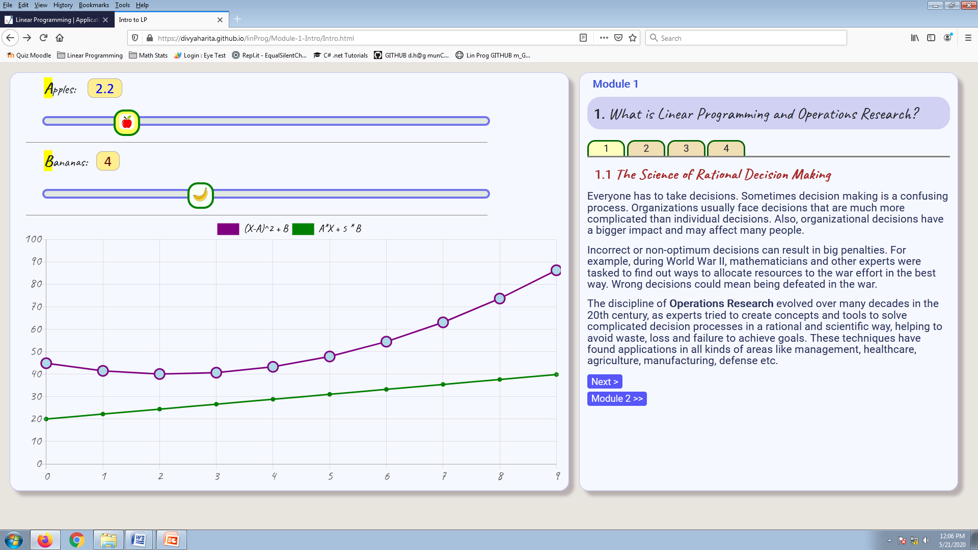

As shown above, Module1 has 4 tabs. In general module-1 contains the definition of Linear Programming, what Linear Programming is all about, need for Linear Programming, application and uses of Linear Programming etc, general guidelines for the user as to how to use this tutorial in order to get full advantage of it.

**Module-2:**

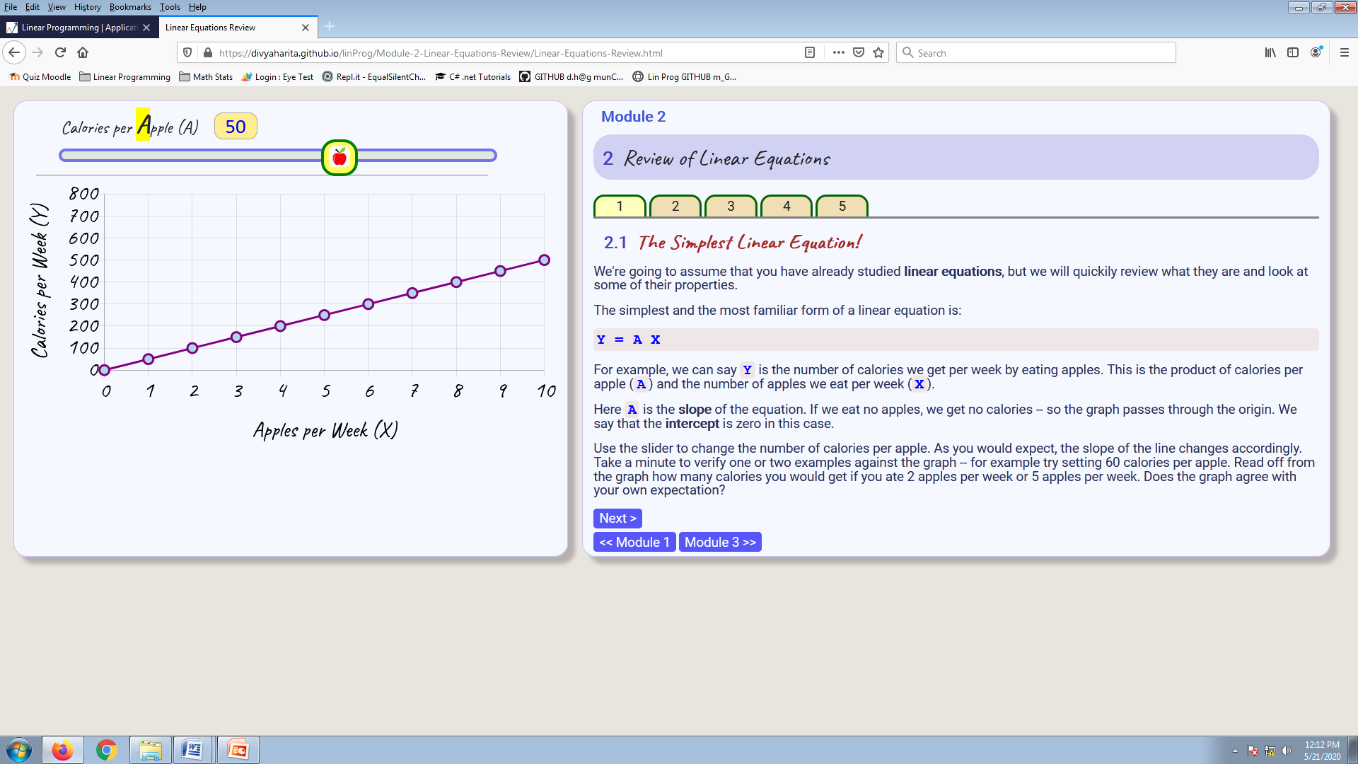

Module -2 focuses mostly on revising the concepts of linear equation, the equation for a straight line, the concept of intercept and a simple example of a linear equation.

**Module - 3**

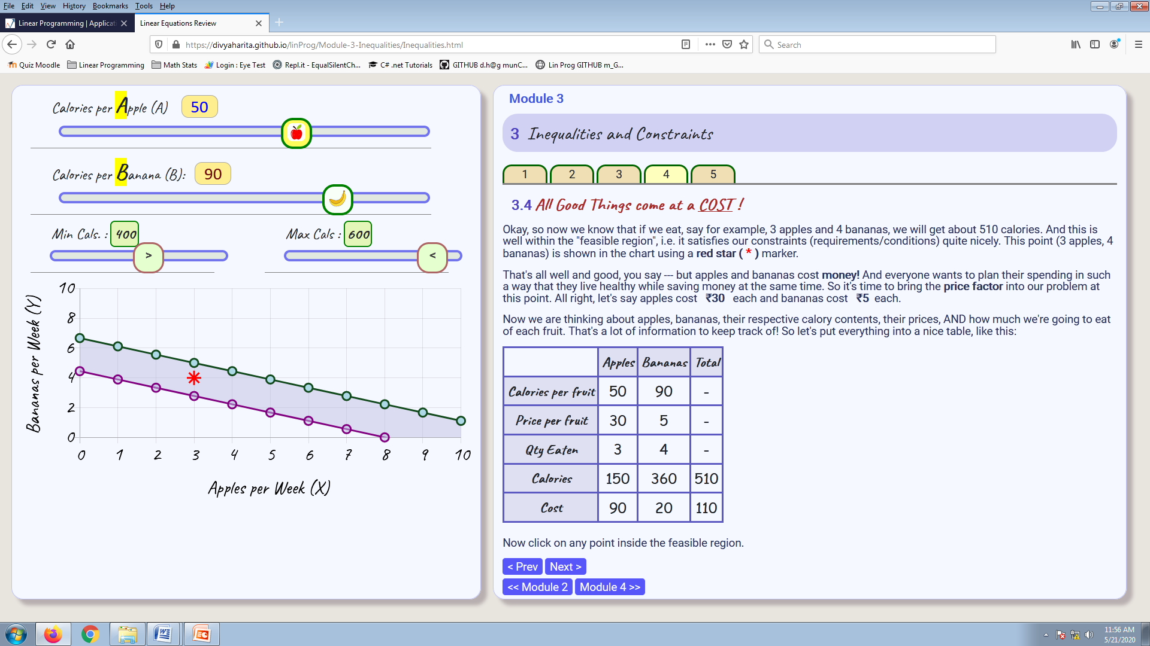

Module 3 focuses on Inequalities and constraints. It describes how the increase or decrease in the total number of calories affects the consumption of the number of apples and bananas consumed. It also demonstrates examples of problems with and without feasible regions.

The different problem parameters and variables are tabulated in a dynamic table. The user can click on any point on the chart to explore the effect of fruit consumption quantities, and to see whether goals are satisfied by any chosen point. The student can also develop an intuitive understanding of the relation between chosen point and the corresponding cost.

**Test Plan and Test Cases**

**Module 1:**

|  |  |  |  |
| --- | --- | --- | --- |
| Test Name | Test Input | Expected Results | Test-case Result |
| Module 1  (LP: Intro) | Click Tab 1 | * Sliders and Demo graph displayed in UI panel . * Section 1.1 content displayed in text panel. | Pass |
| Vary “Apples” slider | * Violet graph changes (parabola). | Pass |
| Vary “Bananas” slider | * Green graph changes (line). | Pass |
| Click Tab 2 | * Same UI Configuration * Section 1.2 content in text panel. | Pass |
| Click Tab 3 | * Same UI configuration * Section 1.3 content in text panel. | Pass |
| Click Tab 4 | * Same UI configuration * Section 1.4 content   In text panel. | Pass |

**Module - 2**

|  |  |  |  |
| --- | --- | --- | --- |
| **Test name** | **Test Input** | **Expected results** | **Test-case Result** |
| Module 2 (linear equations review) | Click Tab 1 | * Graph of linear equation displayed in GUI. * Content of section 2.1 is displayed. * Slider value=50. * Graph passes from origin to (10,500). | Pass  Pass |
| Move the slider to 30 | * Graph passes from origin to (10,300) | Pass |
| Click Tab 2 | * Content of section 2.2 displayed. * Graph of linear equation displayed in GUI. * Intercept message appears below slider. * The graph passes through (0,200) to (10,500). | Pass |
| Module 2 (linear equations review)  (cont’d) | Move the slider to 40 | * Graph passes through (0,200) to (10, 600). | Pass |
| Click on Tab 3 | * Content of section 2.3 displayed. * Graph of linear equation displayed in GUI. * Slider values: 50 and 90. | Pass |
| Set sliders:  A=65;  B=60; | * Graph passes through (0,8.3) to (7,0.75). | Pass |
| Click on Tab 4 | * Content of Section 2.4 displayed in text panel. * Graph of linear equation displayed in GUI. * Slider values: 50 and 90. | Pass |
| Click “**Show answer”** button in text panel. | * Answer displayed in text panel | Pass |
| Set sliders:  A:40;  B:100; | * Graph passes from (0,5) to (10,1) | Pass |
| Click on Tab 5 | * Content of Section 2.5 displayed in text Panel. * Graph of linear equation displayed. * Slider values: 50 and 90. * New slider for changing calories. | Pass |
| Set calories to 300 | Graph passes through (0,3.3) and (6,0). | Pass |

**Module 3:**

|  |  |  |  |
| --- | --- | --- | --- |
| **Test name** | **Test Input** | **Expected results** | **Test case result** |
| Module 3 (Inequalities and constraints) | Click Tab 1 | * Content of Section 3.1 displayed * Graph of linear equation displayed in GUI. * Slider values 50 and 90. | Pass |
| Click **“Show Answer”** button. | * Answer displayed. | Pass |
| Set sliders to 40, 40 and 300 | * Graph passes through (0,7.5) and (7,0.5) | Pass |
|  | Click Tab 2 | * Content for Section 3.2 displayed. * Additional green graph displayed. * New Slider for maximum and calories displayed. | Pass |
|  | Set slider A, B, max, min to (40, 50, 350, 500). | * Green graph passes from (0, 10) and (10, 2). * Violet graph passes from (0, 7) and (8, 0.6). * Region between lines -- shaded violet. | Pass |
|  | Click Tab 3 | * Content for Section 3.3 displayed in Text Panel. | Pass |
|  | Set max, min to 400 and 500. | * Region between lines –shaded red. | Pass |
|  | Click Tab 4 | * Content of Section 3.4 displayed in Text Panel. * Star marker appears at (3, 4) in the graph. | Pass |
|  | Click at (5, 8) in graph area. | * Star moves to (5,8). * Table is updated as follows: | Pass |

**References/Bibliography:**

* Chart.js : www.chartjs.org
* Jquery : www.jquery.com
* Jquery UI : www.jqueryui.com
* Bootstrap : getbootstrap.com
* Math.js : mathjs.org
* W3Schools.org
* Sharma, JK: Operations Research, Theory & Applications
* Video Tutorial on L.P. by Prof. Wen Shen, Penn State University
  + https://www.youtube.com/watch?v=FdKgeeb4q3w